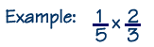
Multiplying Fractions
Step 1: Multiply the numerators.
Step 2: Multiply the denominators.
Step 3: Simplify if possible.

**************************************************************************************************
Multiplying with Mixed Numbers
Step 1: Change the mixed numbers to improper fractions.
Step 2: Multiply the numerators.
Step 3: Multiply the denominators.
Step 4: Simplify if possible (and change back to mixed number if needed).
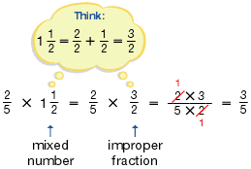

**************************************************************************************************
Multiplying Fractions with Whole Numbers
Change the whole number to a fraction (write over 1) and follow steps above!
Multiplying Fractions
Step 1: Multiply the numerators.
Step 2: Multiply the denominators.
Step 3: Simplify if possible.

**************************************************************************************************
Multiplying with Mixed Numbers
Step 1: Change the mixed numbers to improper fractions.
Step 2: Multiply the numerators.
Step 3: Multiply the denominators.
Step 4: Simplify if possible (and change back to mixed number if needed).

**************************************************************************************************
Multiplying Fractions with Whole Numbers
Change the whole number to a fraction (write over 1) and follow steps above!

