*C:\Documents and Settings\wdl18864\Local Settings\Temporary Internet Files\Content.IE5\S36B2ANH\MC900088460[1].wmf*C:\Documents and Settings\wdl18864\Local Settings\Temporary Internet Files\Content.IE5\3GB3ZR1O\MC900088450[1].wmfDividing Fractions

*\*\*Think SOAR!\*\**

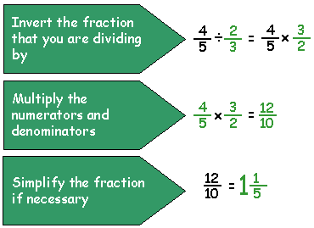 **SAME**

Keep the first fraction the same.

**UNLESS you have a mixed number.

 Rewrite mixed numbers as improper fractions!

 **OPPOSITE**

The opposite of division is  
 multiplication!

 **And RECIPROCAL**

Use the reciprocal of the   
 second fraction! **=**

**Do not forget to change mixed numbers 

as improper fractions BEFORE SOAR!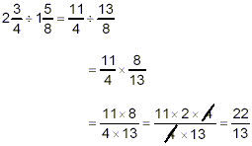

Example:



C:\Documents and Settings\wdl18864\Local Settings\Temporary Internet Files\Content.IE5\S36B2ANH\MC900088460[1].wmfC:\Documents and Settings\wdl18864\Local Settings\Temporary Internet Files\Content.IE5\3GB3ZR1O\MC900088450[1].wmfDividing Fractions

*\*\*Think SOAR!\*\**

** **SAME**

Keep the first fraction the same.

**UNLESS you have a mixed number.

 Rewrite mixed numbers as improper fractions!

 **OPPOSITE**

The opposite of division is  
 multiplication!



**And RECIPROCAL**

Use the reciprocal of the second fraction!



**Do not forget to rewrite mixed numbers

 as improper fractions BEFORE SOAR!

Example:

Dividing Fractions

** Remember that when you divide two numbers, you are finding out how many times the *divisor* fits *into* the *dividend*.

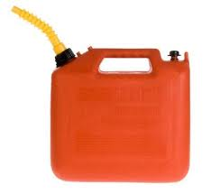

David’s lawn mower holds ¾ gallon of gas. If he has 1 ½ gallons of gas, how many times can he fill up his lawn mower?

**3**

**4**

**3**

**4**

|  |  |  |
| --- | --- | --- |
| You Try! | | |
| $$\frac{5}{6}÷\frac{5}{12}$$ | $$\frac{9}{10}÷\frac{3}{5}$$ | $$2\frac{1}{4}÷\frac{1}{8}$$ |

So, how many ¾’s will fit inside 1 ½ ?

$1\frac{1}{2}$ ÷ $\frac{3}{4}$

$\frac{3}{2}$ ÷ $\frac{3}{4}$

$\frac{3}{2}$ x $\frac{4}{3}$

$\frac{12}{6}$ = 2

¾ fits inside 1 ½ *two* times. David can fill up his lawn mower twice.

Dividing Fractions

** Remember that when you divide two numbers, you are finding out how many times the *divisor* fits *into* the *dividend*.



David’s lawn mower holds ¾ gallon of gas. If he has 1 ½ gallons of gas, how many times can he fill up his lawn mower?

**3**

**4**

**3**

**4**

|  |  |  |
| --- | --- | --- |
| You Try! | | |
|  |  |  |

So, how many ¾’s will fit inside 1 ½ ?

÷

÷

x

= 2

¾ fits inside 1 ½ *two* times. David can fill up his lawn mower twice.