**Ratios**

**What is a ratio?** A ratio is a ________________ of ________ ____________.

**How are ratios like fractions?** They should ______________ be ______________

**Helpful Hint:** ___________ ______________!!!

C:\Program Files\Microsoft Office\MEDIA\CAGCAT10\j0299611.wmf

3 ways to write a ratio

Example: Let’s say that out of 10 dentists, 7 recommend Crest. That means 3 dentists do not recommend Crest. The ratio of dents who recommend Crest to those who do not could be written in three ways:

______________ ______________ ______________

It is very important to notice what the question asks first when setting up your ratio.

**Write the ratios in three different ways.**

1. Triangles to squares

2. Squares to triangles

3. Shapes to triangles

4. Squares to shapes

**Write the ratio of burgers to chips in three different ways.**

**Write the ratio of chips to burgers in three different ways.**

Since a ratio can be written as a fraction, they can also be simplified like a fraction.

10/15 = ____________ 10**:**15 = ___________ 10 to 15 = __________

These are called _____________ ___________.

**Simplify these ratios**

**12 : 14 = _____________ 20 : 24 = ____________ 10 : 25 = ____________**

**8 : 56 = _______________ 3:16 = _______________ 7:20 = _____________**

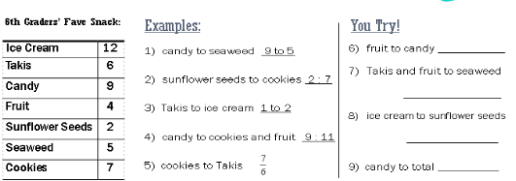

**You try**!

6) fruit to candy _____________

7) Takis and fruit to seaweed ________

8) Ice cream to sunflower seeds ___________

9) candy to total _________

**Examples**:

1) candy to seaweed _____________

2) sunflower seeds to cookies ________

3) Takis to ice cream ___________

4) candy to cookies and fruit _________

5) cookies to Takis __________

Katie wants to divide her 30 flowers into two groups, so that the ratio is 2 to 3.

**Step 1** - Use a triple number line to show a ratio of 2 to 3.

There are ____ flowers in one group and ____ in the other.

Divide 28 cans of soda into two groups so the ratio is 3 to 4.

There will be ______ sodas in the first group and ______ in the second.